- Housing
- We will be talking more about the housing market over the next few months.
- Our concern about house price inflation is based on the risk it poses to financial stability and the broader economy. Although it has not been a major factor in recent years, high rates of house price inflation can spill over into stronger spending and pressure on consumer price inflation. And the more that house prices get out of line with historic relativities, the greater the risk of a sharp correction, leading to financial instability.
- Analysis by the IMF in 2013 indicated that New Zealand, along with Norway, had the greatest deviation in house price to income ratios from its historic trends among several advanced economies.
International house price-to-income ratios
(deviation from historical average, 2013)
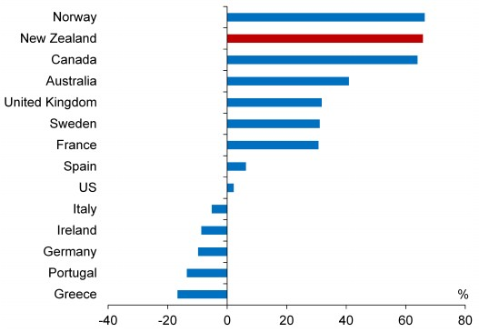
Source: IMF
- Our focus is mainly on the Auckland and Christchurch markets as they represent around half of the national real estate market: they are where the housing shortages are greatest and where market pressures are the most intense. Auckland and Christchurch house prices are 39 and 27 percent respectively above their 2007 levels.
- House price inflation slowed as the Loan-to-Value ratio restrictions and the rise in mortgage interest rates helped to constrain demand, but appears to be increasing again in Auckland due to rising household incomes, falling interest rates on fixed- rate mortgages, strong migration inflows and continued market tightness[4]. Annual house price inflation measured on a three-month moving average basis is currently 10.9 and 7.4 percent in Auckland and Christchurch respectively, and 1.1 percent in the rest of New Zealand. We will have a clearer assessment when the February/March REINZ data is available.
House price inflation
(annual, 3-month moving average)
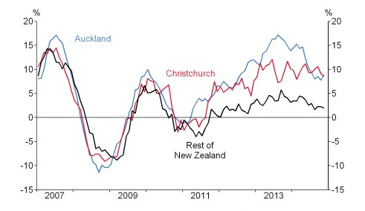
Source: REINZ, RBNZ estimates.
- Resolving the housing shortages is key. In Christchurch this issue is expected to be resolved, albeit with longer delays than originally anticipated. In Auckland, much more needs to be done, especially in creating opportunities for residential construction in Auckland central. Auckland’s housing shortage is estimated to have increased over the past year to between 15,000 and 20,000 dwellings, and the Auckland Council estimates that 10,000 houses a year will be required for the next 3 decades. Residential building permits are currently running at an annual rate of 7,700 – a 70 percent increase over 2012 and twice the 2011 level, but well short of the increase that needs to be sustained over a long period.
- We will continue to monitor housing developments carefully, and the role that the banking system may be playing in contributing to pricing pressures in the housing market.

